Use Case 1: One-Time Manual Data Load (Access Key Method)
Scenario:
A team needs to load historical CSV files from S3 into Snowflake one time only.
Exploration Questions
- What Snowflake objects are mandatory to perform a one-time manual load?
A one-time manual load in Snowflake requires a warehouse, file format, external stage with AWS credentials, target table, and the COPY INTO command.
- Stage (External Stage with S3 path)
- Table (Target table)
- File Format (CSV)
- Warehouse (for compute)

- Where and how are AWS credentials stored in Snowflake for this method?
AWS credentials are stored inside the External Stage definition in Snowflake using AWS_KEY_ID and AWS_SECRET_KEY.
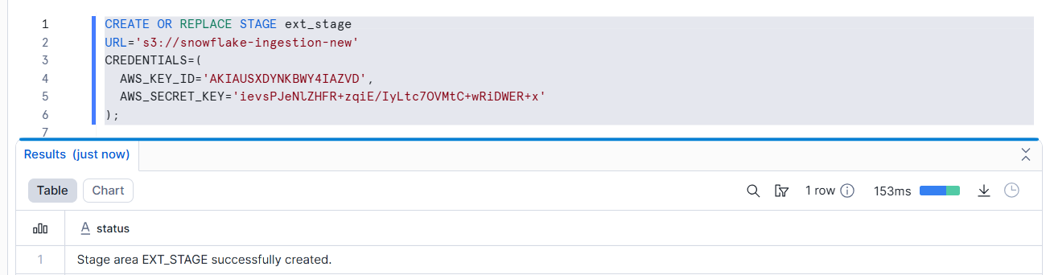

- What minimum S3 permissions are required for successful loading?

- s3:GetObject – to read the data files from S3
s3:GetObject is an AWS S3 permission that allows Snowflake to read data files from an S3 bucket. It must be granted via IAM policies, not ACLs.
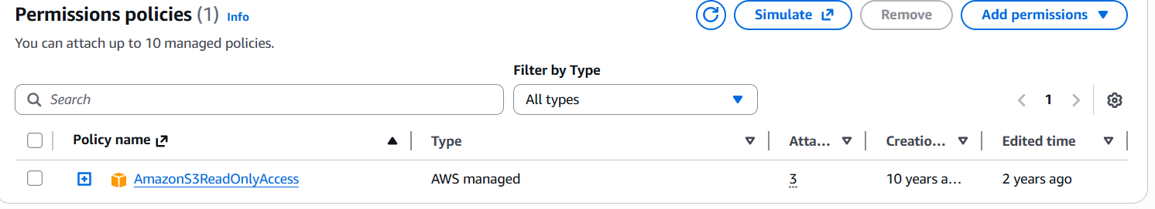
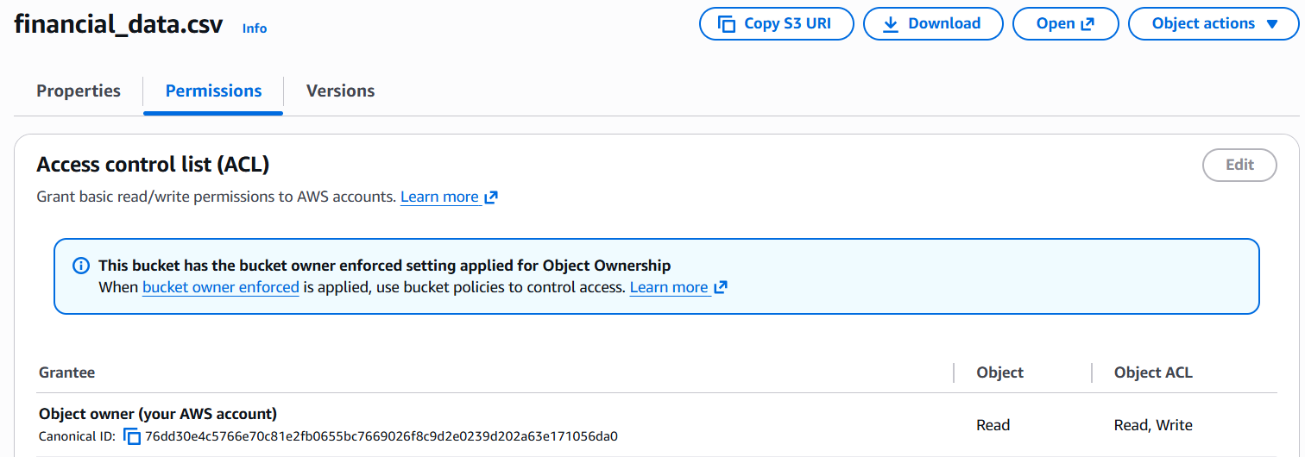

- What happens if credentials are revoked after the stage is created?
Revoke = To cancel or take back access or permission.
If the credentials are revoked after the stage is created, Snowflake will lose access to the S3 bucket and any data load operation (COPY INTO or LIST) will fail until valid credentials are provided again.

- How can you confirm which files were successfully loaded?
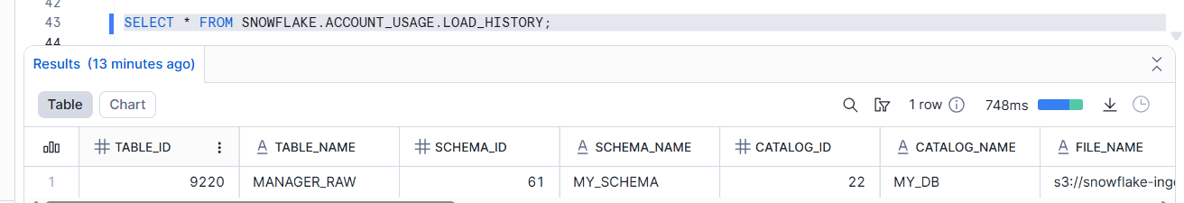

SELECT * FROM SNOWFLAKE.ACCOUNT_USAGE.LOAD_HISTORY;
Successful file loads can be confirmed using the SNOWFLAKE.ACCOUNT_USAGE.LOAD_HISTORY view, which displays details such as file name, table name, and load status.

- What happens if the same file is re-uploaded to S3 and reloaded?
Snowflake will NOT load it again.Because it remembers the file_name,size so it knows it already loaded.when FORCE = TRUE is used.
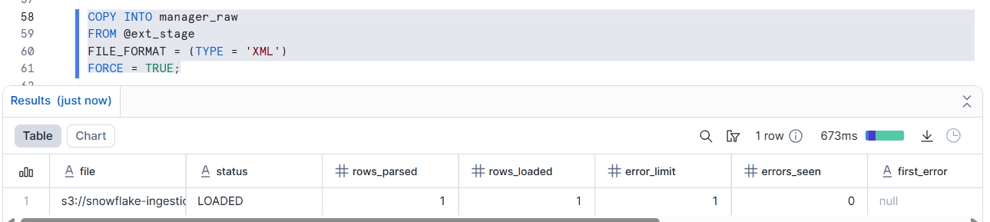

- How does Snowflake prevent or allow duplicate loads?
Snowflake tracks file history automatically.And it also use FORCE = TRUE.
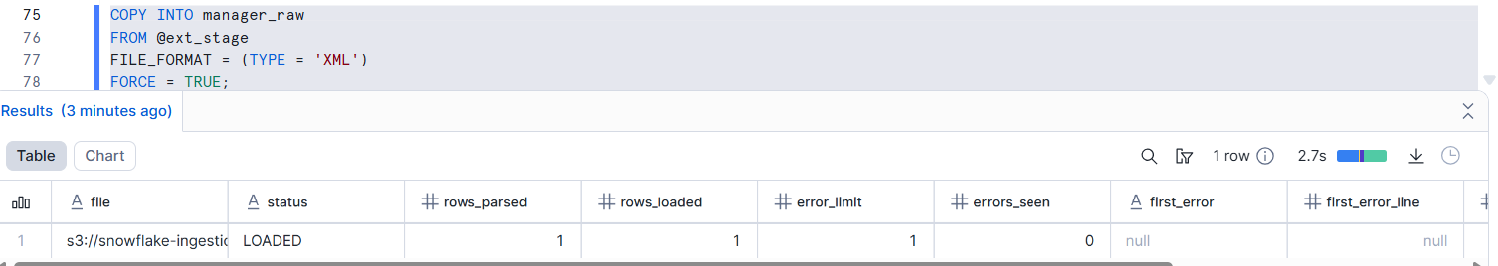

- What security risks are visible during implementation?
No major security risks are visible during implementation because AWS credentials are not hardcoded. Access to S3 is managed securely using a Snowflake storage integration with an IAM role, making it safe for production use.
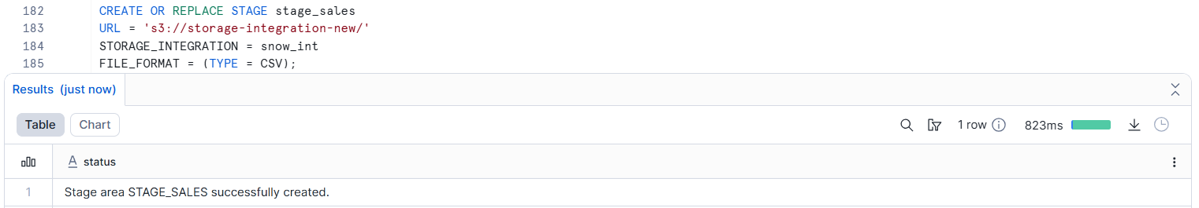

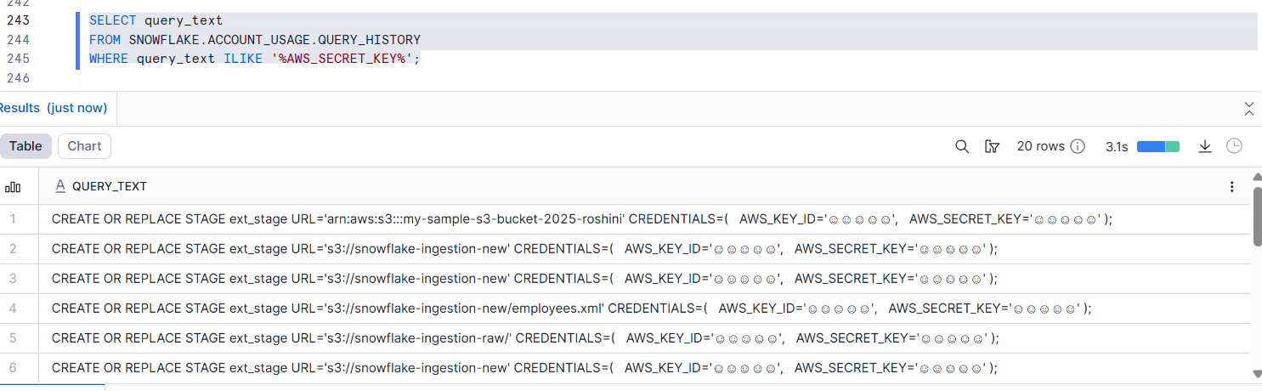

- How would this approach behave in a production environment?
Snowflake safely reads data from S3 without storing passwords, so it works securely in production.
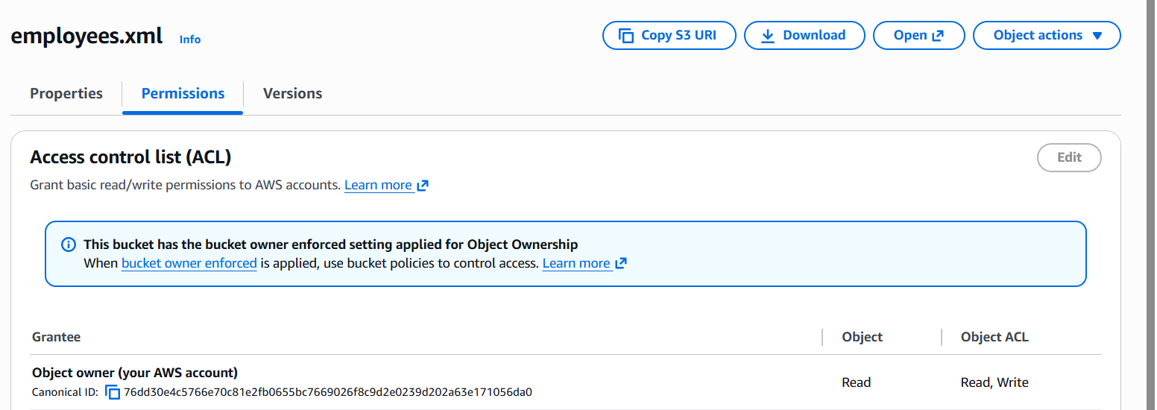

- Why is this method discouraged for long-term use?
Storing passwords for a long time is risky, so this method is avoided.

Use Case 2: Secure Batch Loading (Storage Integration + COPY INTO)
Scenario:
A finance team loads daily CSV files securely from S3 using IAM roles.
Exploration Questions
- What AWS and Snowflake components are involved before loading begins?

AWS Components
- S3 Bucket – Stores the data files (CSV).
- IAM Role – Allows Snowflake to access S3 securely.
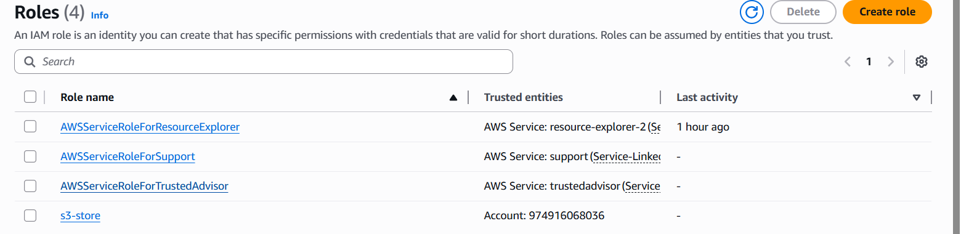
- IAM Policy – Grants permissions like s3:GetObject and s3:ListBucket.
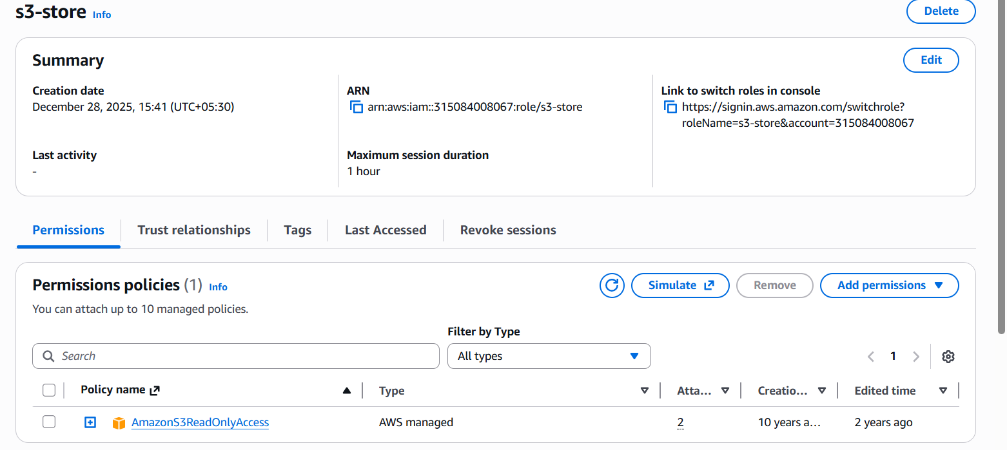

🔹 Snowflake Components
- Storage Integration – Connects Snowflake to AWS securely using IAM role.
- External Stage – Points to the S3 bucket location.
- File Format – Defines file type (CSV, JSON, etc.).
- Target Table – Where data will be loaded.
- Warehouse – Provides compute power for COPY command.

- How does Snowflake assume the IAM role during loading?
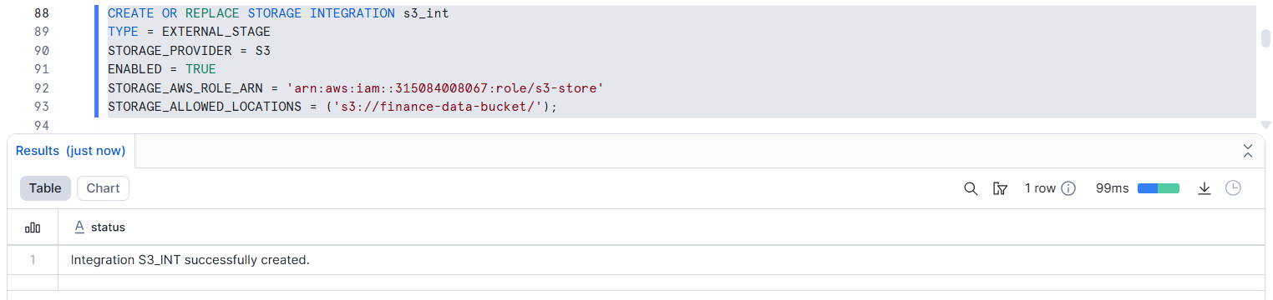
- STORAGE_AWS_ROLE_ARN → IAM role Snowflake will assume
- Snowflake uses AWS STS(security token service) internally

- What is the purpose of STORAGE_ALLOWED_LOCATIONS?
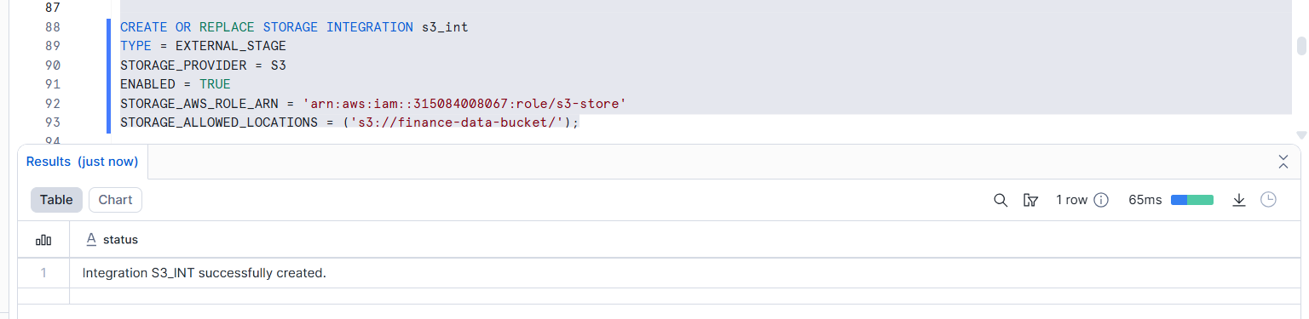
- STORAGE_ALLOWED_LOCATIONS is used to restrict which S3 locations Snowflake is allowed to access.
- It acts as a security control.

- What happens if Snowflake tries to access a path outside the allowed location?
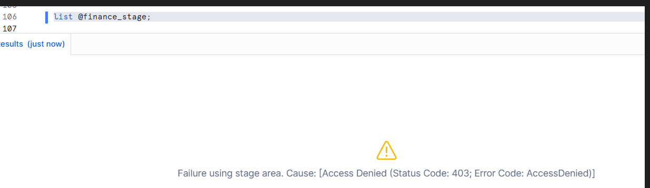
If Snowflake accesses a path outside STORAGE_ALLOWED_LOCATIONS, the operation fails with an access denied error to protect data security.

- Can multiple stages share the same storage integration? Why?
Yes, multiple stages can share the same storage integration because the integration controls access at the account level, allowing reuse for different S3 paths.
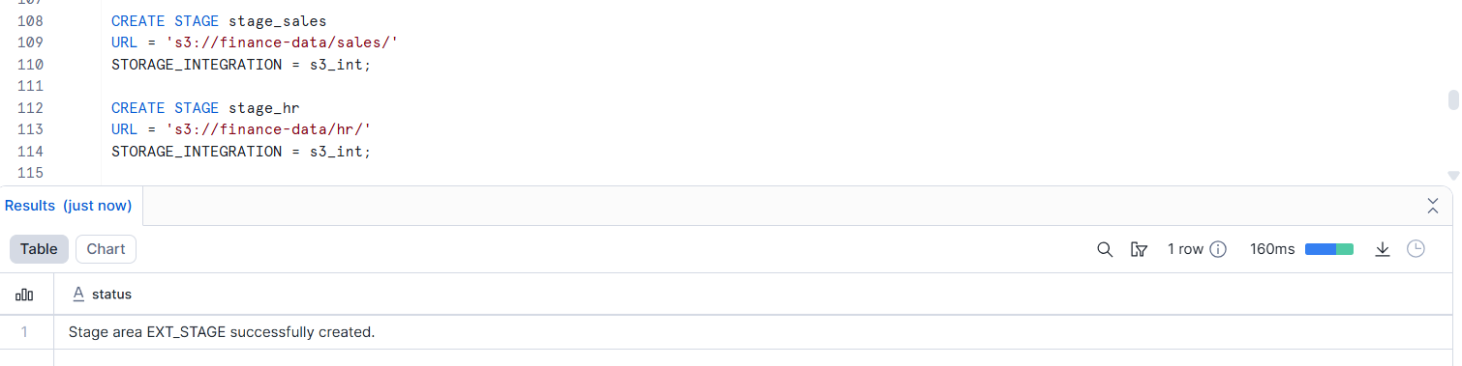
WHY ?
- Multiple stages can point to different folders inside the same allowed S3 location
- This avoids creating multiple IAM roles

- How does Snowflake track loaded vs unloaded files?
Snowflake tracks loaded and unloaded files using internal load metadata generated during the COPY INTO operation.
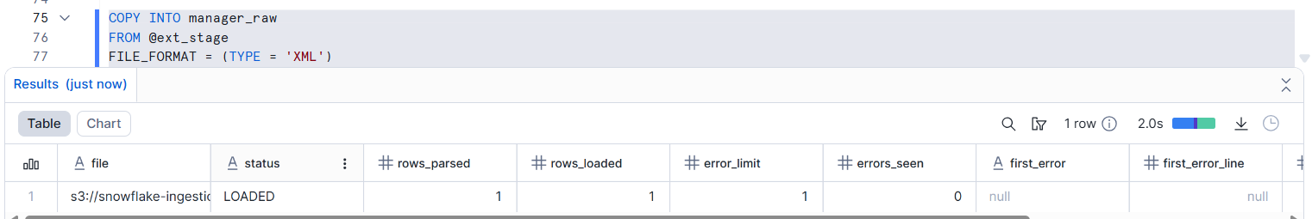

- What happens when new files are added to the same S3 folder?
When new files are added to the same S3 folder, Snowflake loads only the new files and skips already loaded files using its internal load history tracking.
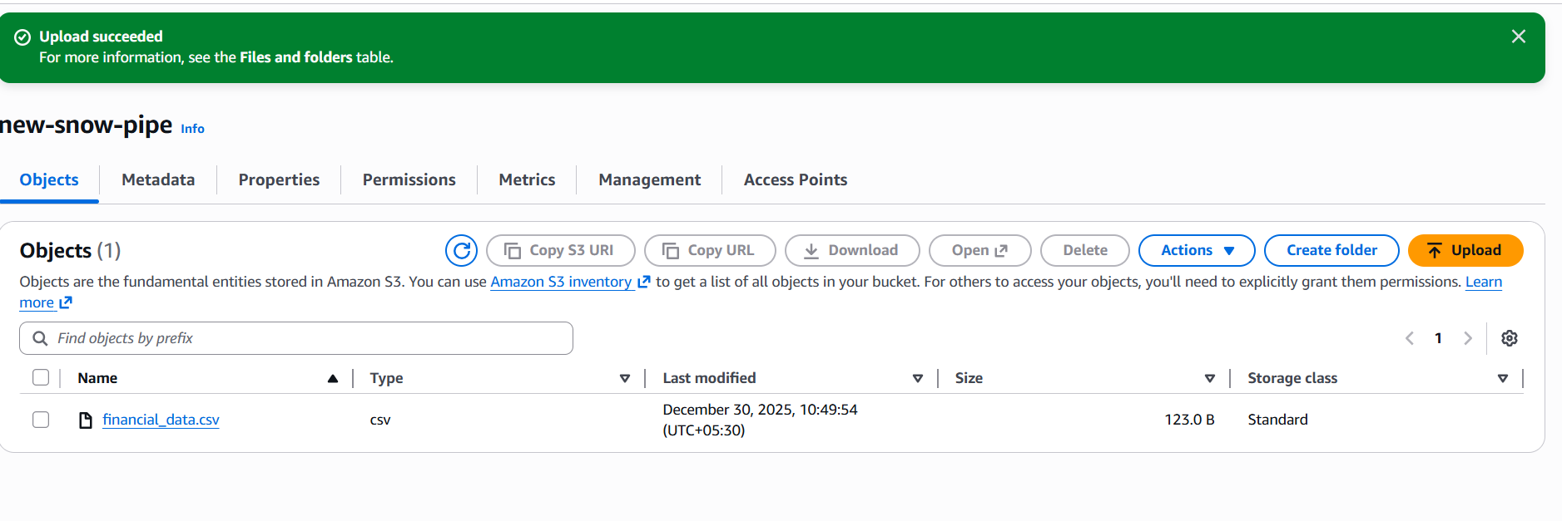
In-case it is different file means,it stored:
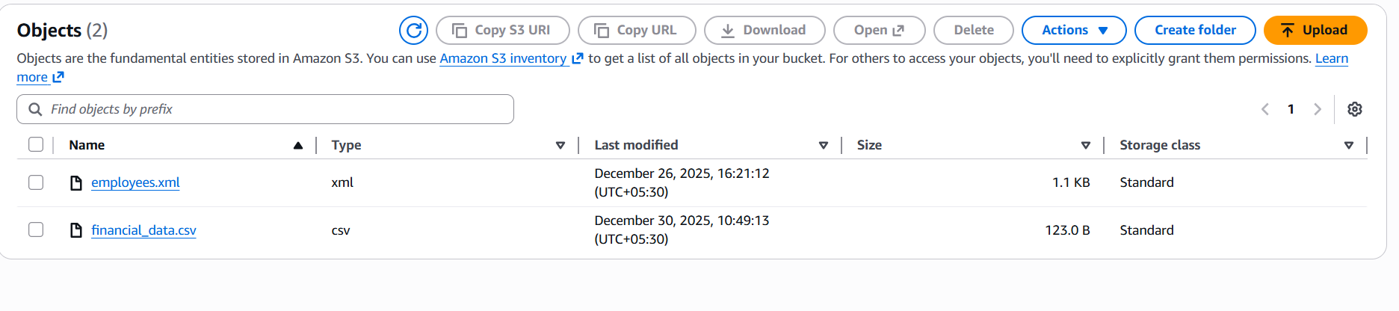

- How does this method compare to access-key loading in terms of security?
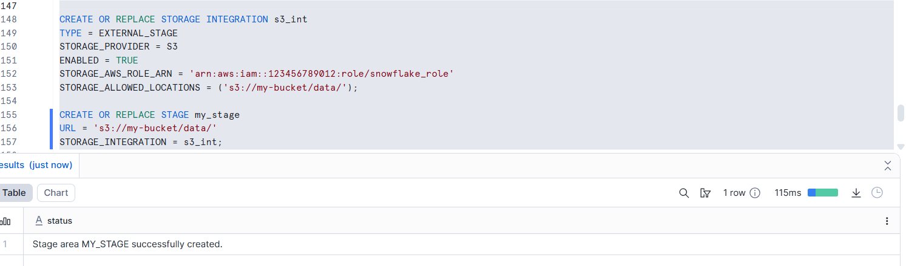
- It is secure
- Used in production
- Uses IAM role
- No access keys stored

- How can this method be automated using Snowflake Tasks?
Snowflake Tasks can be used to automatically run the COPY INTO command on a schedule, so new files from S3 are loaded without manual effort.
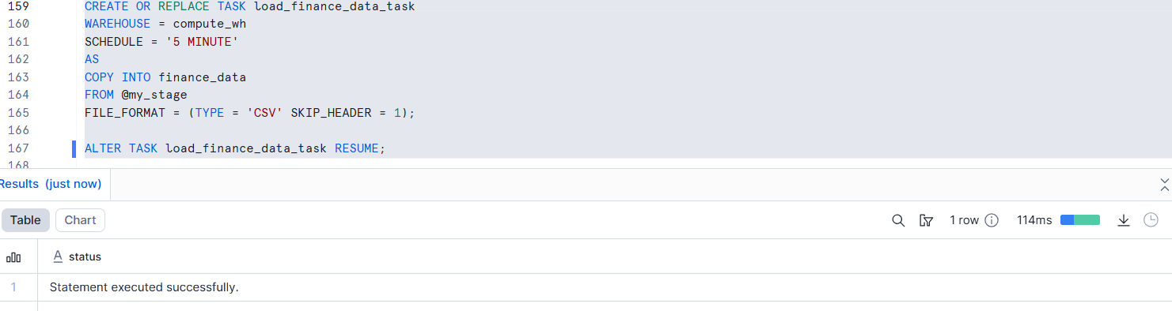

- What production-level advantages does this approach provide?

- More secure (no access keys used)
- Automatic data loading using tasks
- No duplicate data
- Works well for large data
- Safe and reliable for production use

Use Case 3: Near Real-Time Ingestion (Snowpipe)
Scenario:
An application generates CSV files every few minutes and requires automatic ingestion into Snowflake.
Exploration Questions
- What triggers Snowpipe to start loading files automatically?
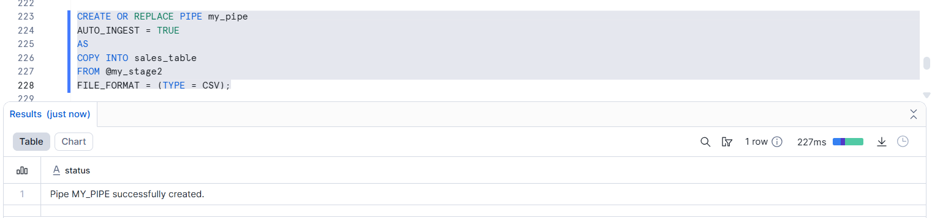
- This query triggers Snowpipe automatically
- Uses AUTO_INGEST = TRUE
- Works when S3 event notification is configured

- Why is an event notification required in AWS?
An event notification is required so AWS can inform Snowflake immediately when a new file is uploaded to S3.
Without this notification, Snowflake will not know that a new file has arrived.

- Which Snowflake object listens to file arrival events?
Snowpipe is the Snowflake object that listens to file arrival events.


- Does Snowpipe require a virtual warehouse? Why?
No, Snowpipe does NOT require a virtual warehouse because it uses Snowflake’s serverless compute to load data automatically.

- How does Snowpipe ensure files are loaded only once?
Snowpipe ensures files are loaded only once by tracking file metadata such as:
- File name
- File size like that.
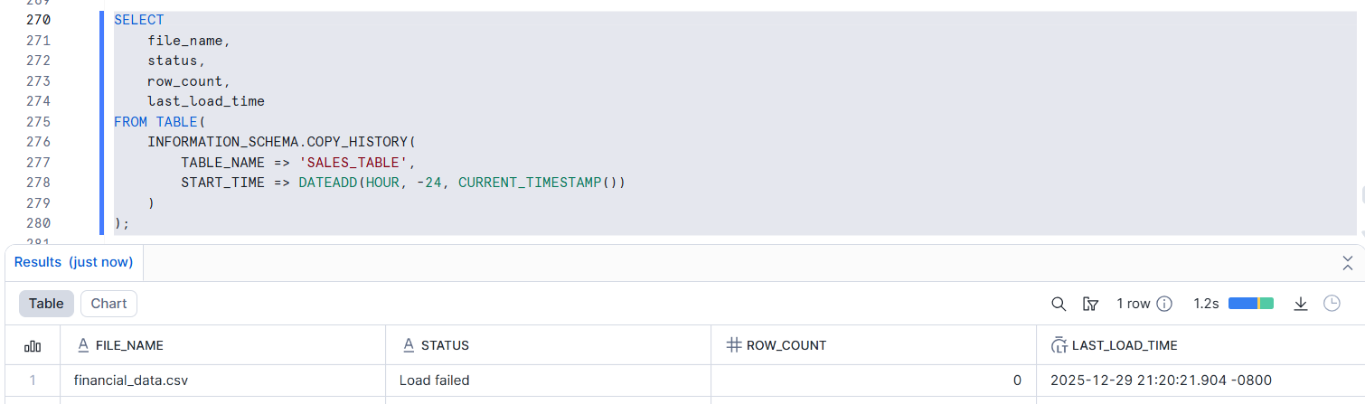

- What happens if Snowpipe is paused?
If Snowpipe is paused, new files will NOT be loaded automatically, even if they arrive in S3.
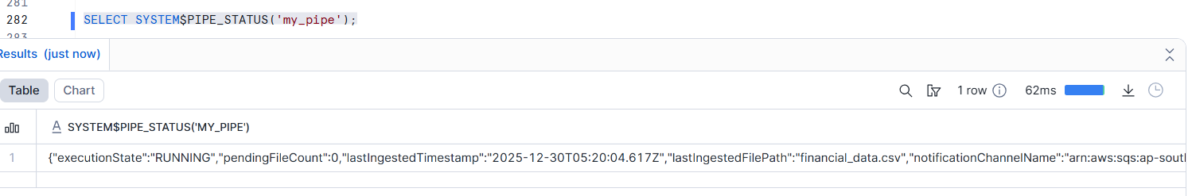

- How are failed files handled in Snowpipe?
Check failed files using:
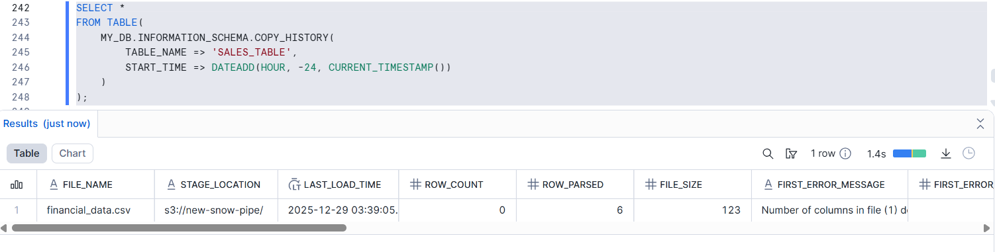
Snowpipe logs failed files but does not reload them automatically.Manual reprocessing is required.

- How can you monitor Snowpipe ingestion status?
Check Pipe Status:
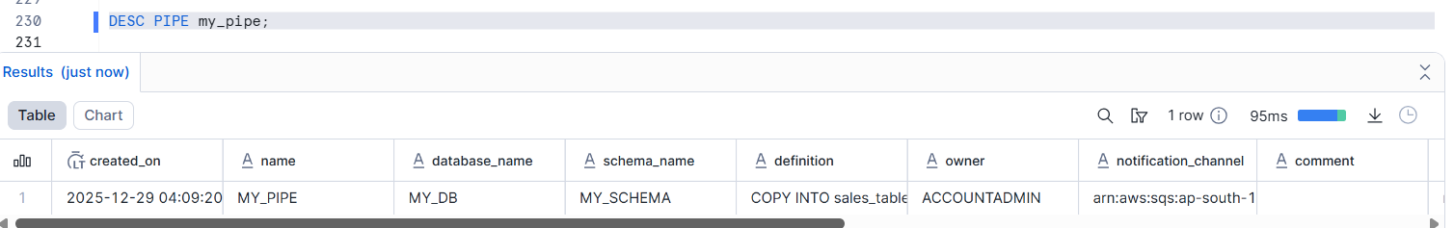

Account-Level Monitoring:
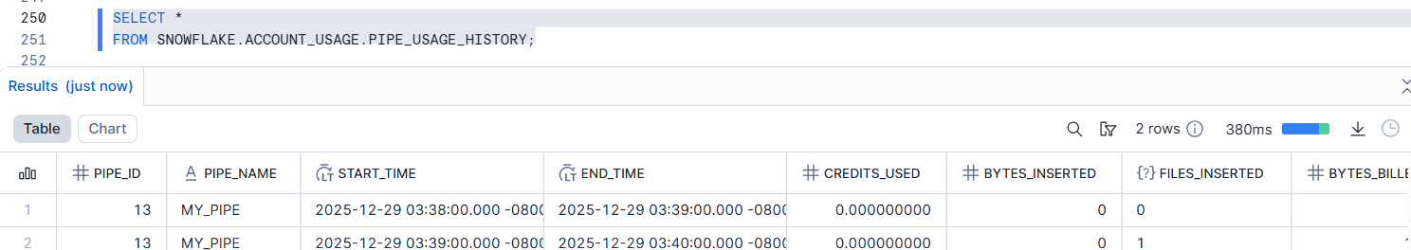

Snowpipe ingestion is monitored using COPY_HISTORY, DESC PIPE, and Snowflake account usage views, which show loaded files, failures, and pipe status.

- What are the cost implications of Snowpipe vs batch loading?
Snowpipe costs more because it loads files automatically one by one, while batch loading is cheaper because it loads data in bulk using a warehouse.
- Snowpipe is an automatically , Loads every small file immediately
- Batch Loading is a manual process , You pay only for warehouse time

- In which scenarios is Snowpipe the best architectural choice?
When files keep coming again and again and you want Snowflake to load them automatically without manual work, Snowpipe is the best choice.


- Snowpipe is the best architectural choice when data arrives continuously and needs to be automatically ingested into Snowflake without manual intervention.

